**IT24103994**

**Nethma L.W.K.**

**IT2120 - Probability and Statistics – Lab Sheet 06**

**Exercise**

1. i)

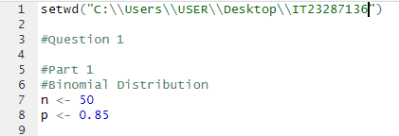

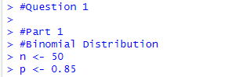

ii)



02)

i)

ii)

iii)

